**Banksea Monthly Updates-August 2022**

Dear Members.

Welcome to the Banksea regular updates, in which the team will provide monthly updates. We hope you all enjoy the article and get a lot from it.

**August 2022**

The past month was also some interesting news.. The main things were:

* **Partnership with Dtools Team**
* **Published the introduction of Banksea Oracle Technical Architecture**
* **Banksea Was featured in the NFT Oracle report from HuobiTech**.

**Partnership with Dtools Team**

We are excited to announce that our partnership with @DtoolsTeam Banksea will provide NFT data analysis and NFT valuation for Dtools, allowing users to access the data powered by Banksea easily.

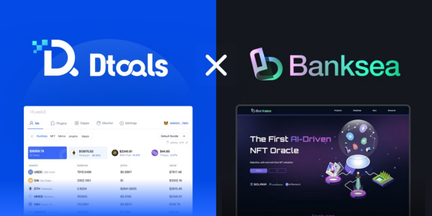

<https://twitter.com/banksea_finance/status/1557569950063083520>

**Published the introduction of Banksea Oracle Technical Architecture**

Last month we published the introduction of Banksea Oracle Technical Architecture. In this article, you can learn the technical of Banksea NFT Oracle. You can read the article on [Banksea Medium](https://medium.com/@BankseaFinance/banksea-oracle-technical-architecture-6dbfb97e5543?source=social.tw" \t "_blank).

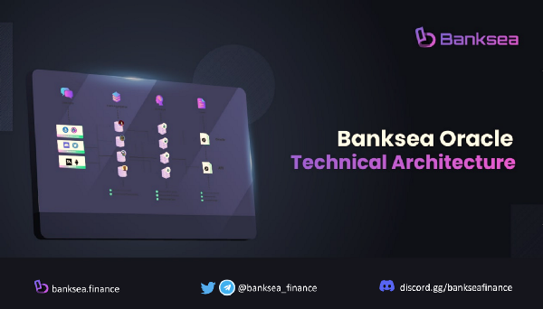

<https://twitter.com/banksea_finance/status/1560639716088696832>

**Banksea was featured in the NFT Oracle report from HuobiTech**.

We are super happy to be featured on HuobiTech Twitter. The report contains Banksea smart contracts and off-chain network of AI nodes.

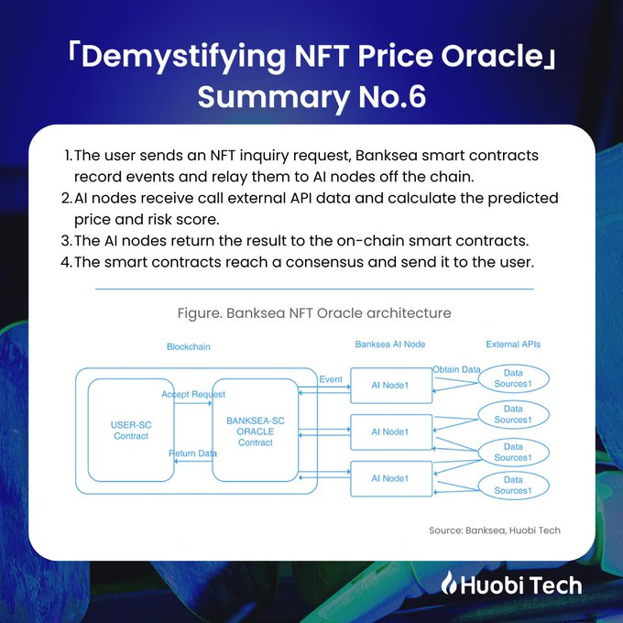

<https://twitter.com/HuobiTech/status/1564141526166282240>

## **The Wrap-up**

It’s been a busy month and full of news. The team is working hard for the project's success and is always happy to hear your opinion and feedback.

We look forward to hearing more from you.

**Join and subscribe for more exciting updates !!! ✅**

**👏**[**Website**](https://banksea.finance/)**|**[**Twitter**](https://twitter.com/banksea_finance)**|**[**Discord**](http://discord.gg/F4AcB4ycCQ)**|**[**Telegram**](http://t.me/banksea_finance)**|**[**Medium**](https://medium.com/@BankseaFinance)**👏**